Solution: Render a large list using SectionList

Overview
In this reading, you will review the solution code for the exercise.
The code block below outlines the outcome of the exercise in its entirety.

MenuItems.js

App.js
The code above produces the following output on the emulator with a scrollable screen:
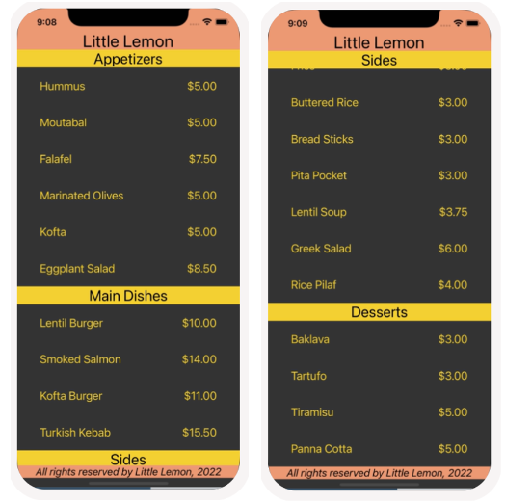

Procedure
Next, review the breakdown of the individual steps below.

Step 1: Update the MenuItems component to use SectionList
Within the existing MenuItems component, render the SectionList component instead of FlatList and pass to it the array from this scenario as shown below.
Make sure to use the updated array!

Step 2: Render Section Header
Render the section headers using the code below.

Step 3: Style the component
Once you have coded a working component, it is time to style it. In this step, you will style the MenuItems component to match the screenshots displayed above.
…

